**Creating an External Style Sheet**

* External style sheets are separate documents containing nothing but style rules.
* You attach these style sheets to HTML documents using a link reference, effectively allowing you to attach a single style sheet document to as many Web pages as you like.
* In this way you only need to change **one style sheet document** to update the formatting of elements **across every page** to which the style sheet document is attached.

**Step 1**: Open a new blank document in Notepad++ and copy the styles provided below.

h1 { color: #009; font-size: 1em; margin-bottom: .3em; text-align: center; text-decoration: underline; }

table { width: 290px; margin-left: auto; margin-right: auto; }

th { padding: .2em; }

td { background-color: #ffc; border: 1px solid #900; padding-left: .5em; padding-right: .5em; }

#trHeader { color: #900; text-decoration: underline; }

.centerCell { text-align: center; }

**Step 2**: Save the file named as **StyleSheet** with a **.css** extension within the directory you’re using for your files

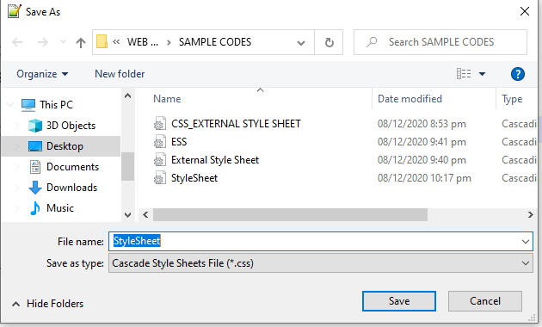

**Step 3**: Open the HTML document to which you want to attach the style sheet.

* + Within the head section of each document, insert a <link> tag with a rel attribute set equal to stylesheet, and a type attribute set equal to text/css.
  + Add a final attribute to the <link> tag, href, and set it equal to the appropriate pathname of the .css file you saved in Step 2.

**HTML Code Linked with CSS External Style Sheet**

<!DOCTYPE HTML>

<html>

<head>

<meta charset="UTF-8">

<title>Embedded Style Sheet</title>

<link href="StyleSheet.css" rel="stylesheet" type="text/css">

</head>

<body>

<div>

<h1>All-time NBA Record- Points Leader</h1>

<table class="center">

<tr id="trHeader">

<th>Rank</th>

<th>Player</th>

<th>Points</th>

</tr>

<tr>

<td class="centerCell">1</td>

<td class="centerCell">Kareem Abdul-Jabbar</td>

<td>38,387</td>

</tr>

<tr>

<td class="centerCell">2</td>

<td class="centerCell">Karl Malone</td>

<td>36,928</td>

</tr>

<tr>

<td class="centerCell">3</td>

<td class="centerCell">Lebron James</td>

<td>34,241</td>

</tr>

<tr>

<td class="centerCell">4</td>

<td class="centerCell">Kobe Bryant</td>

<td>33,643</td>

</tr>

</table>

</div>

</body>

</html>